FMX Mobile Application Development

Hello FireMonkey
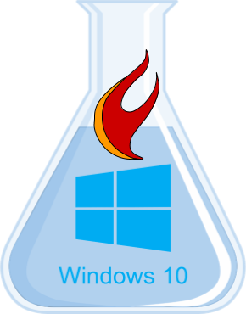
Lab Exercise
- Create a FireMonkey app for Windows
- Add a TTabControl, then right-click and “Add TTabltem”
- Include TLabel, TButton, TEdit, & TListBox on one of the TTabItems
- Notice TLabel & TButton have Text instead of Caption properties
- Notice the TTabControl has TabPosition of PlatformDefault
- In the OnClick event handler add the following code:
  - ListBox1.Items.Add(Edit1.Text);
- Compile and run your app on Windows

